# How to create a private GitHub repository for class

Last updated 1/20/19

If you don't have one already, be sure to create a github account. Then, be sure to register your account with [GitHub for Education](https://education.github.com/) to receive free unlimited private repositories. Note that you must make your repository private!

1. Create a new private repository by clicking on the plus (+) icon in the top-right of GitHub.

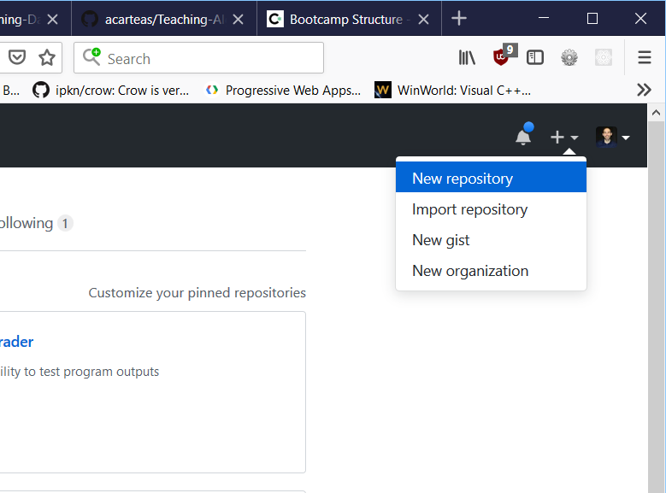

1. Fill out the repository details. Be sure to mark the repository as private. If you are using Visual Studio, I highly recommend that you add the preconfigured VisualStudio .gitignore file (near bottom of screenshot). If you are using another IDE, be sure to select the .gitignore file for your development environment.

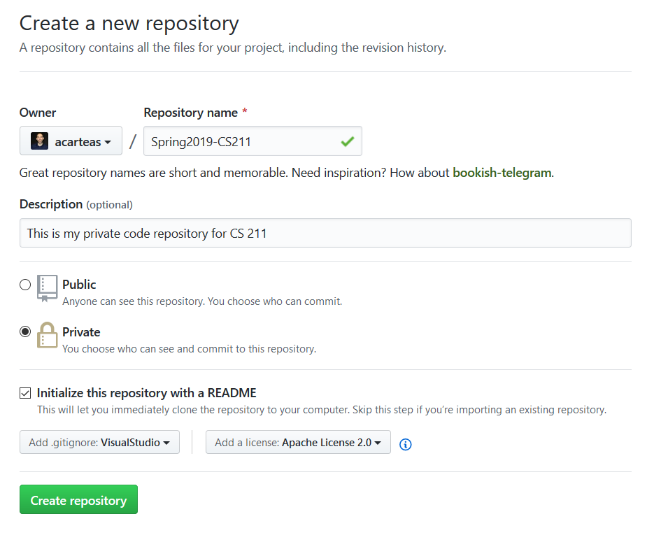3. With your repository created on GitHub, you must now clone the repository onto your local machine. All of our lab machines in BSS 313 should have TortoiseGit installed. If you are on your own personal computer, feel free to use whatever software you'd like. If you are using TortoiseGit, right click on whitespace in windows explorer and select "Git Clone…"

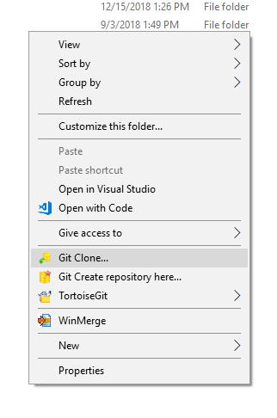

4. Be sure that the URL is correctly pointing to the GitHub repository that you created in step #2. Click OK when ready.

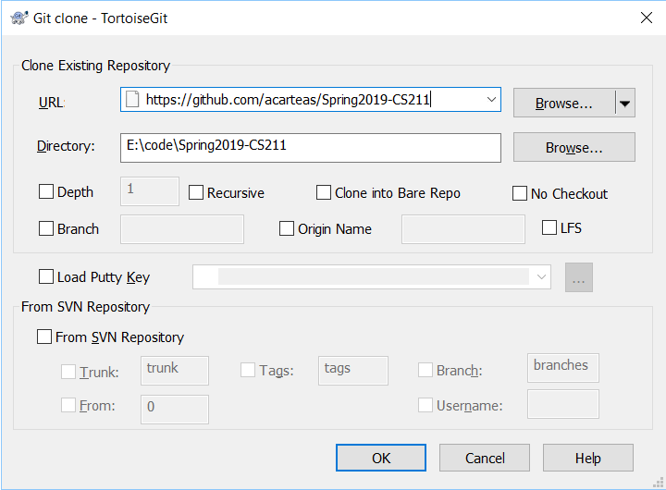

5. You should see a success message indicating that the repository was cloned.

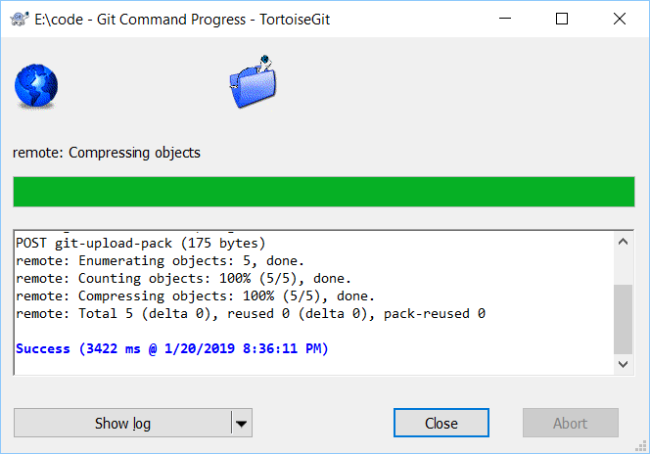

6. Now you can edit files as you would normally. When you have made sufficient progress (e.g. implemented a new feature) or are done programming for the moment, right click in the cloned folder and select "Commit". Enter your commit message and click the "Commit" button.

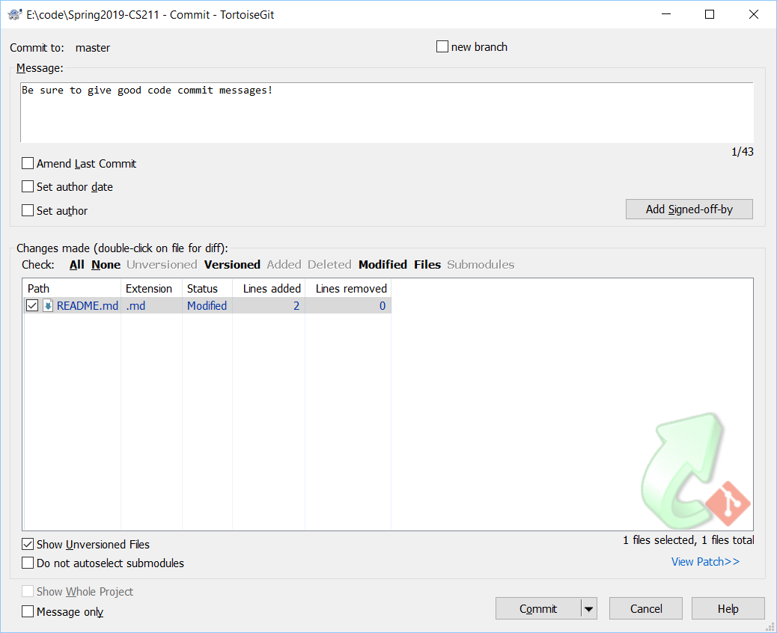

7. Again, you should see a success message. Click the "Push" button to send the changes to GitHub

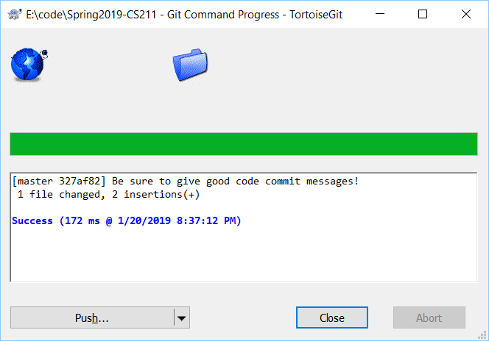

8. Leave all the settings defaulted and click the "OK" button.

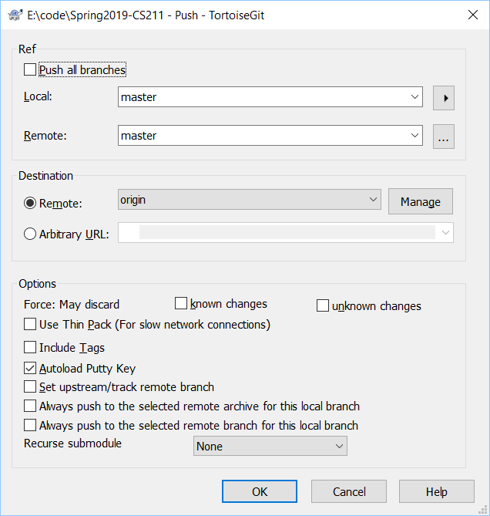

9. Again, you should see a success message:

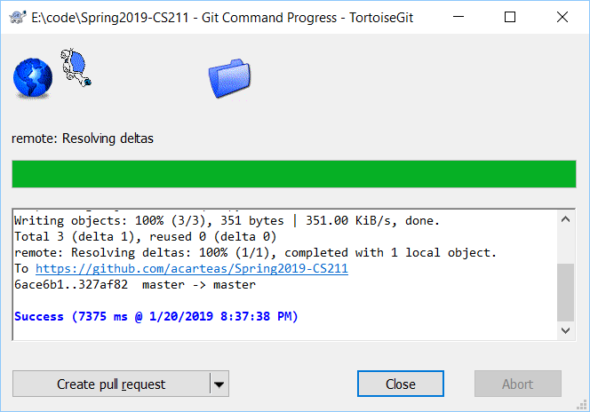

10. And navigating back to GitHub, you should see that your changes have taken hold!

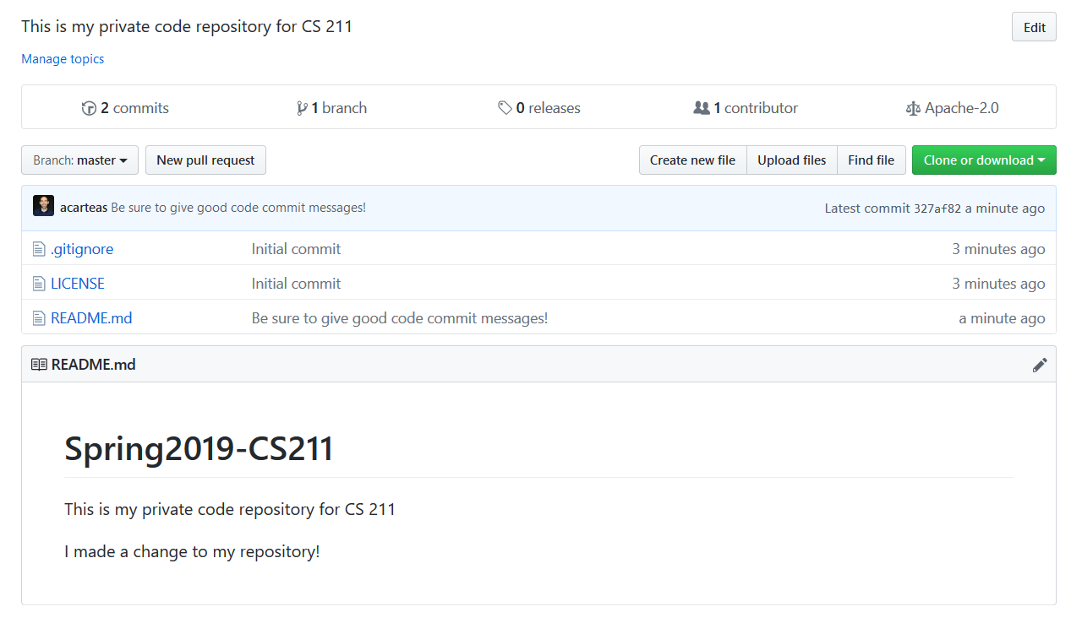

# Adding me as a collaborator to your private repository

Since your repository is private, you will need to add me as a contributor. On your project's GitHub page, click the "Settings" tab on the far-right. Then click the Collaborators option. Enter my name (acarteas) in the search box and click the "Add Collaborator" button. You should be good to go!  
 